FINAL REPORT

ANALYSIS AND RECOMMENDATIONS

## Analysis:

* Casual members have longer ride durations as compared to Subscribers

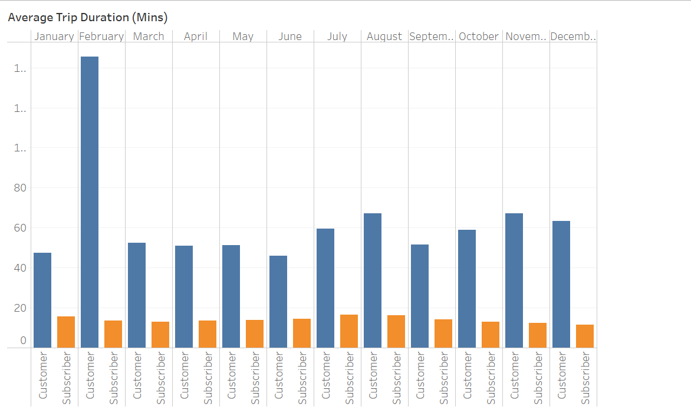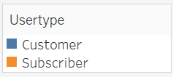

* Annual members have higher trip frequencies as compared to Casual Members
* Bikes Peak usage with increase user count is in summer vacations

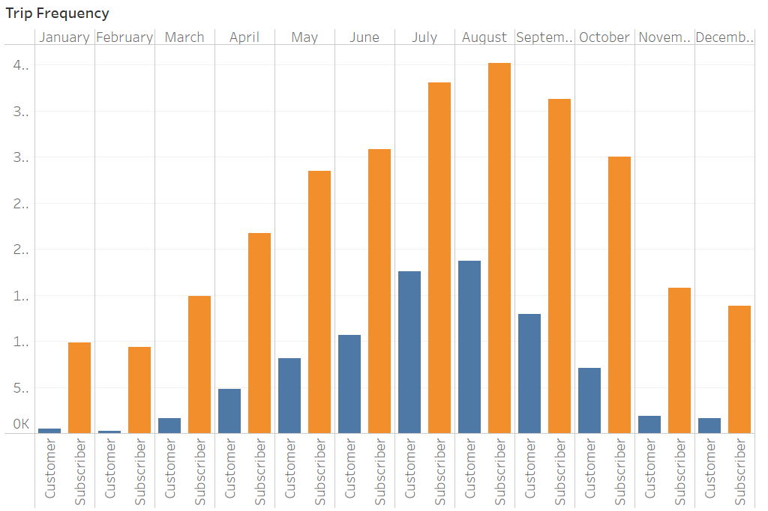

* Casual Members use bikes more on weekends and Subscribers on weekdays

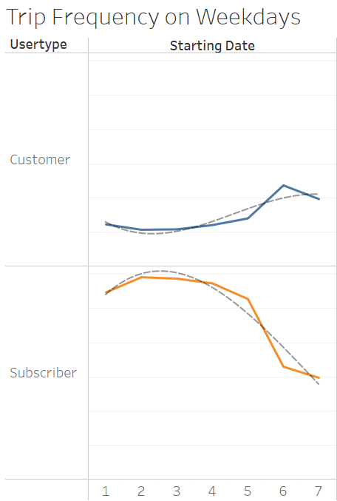

* Peak hours are mostly in the evening

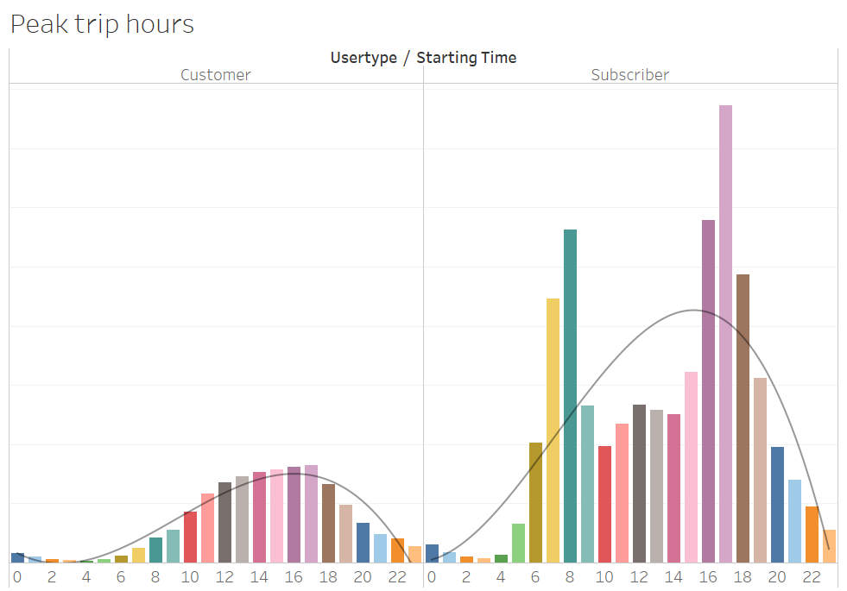

## 

## Recommendations:

* The digital marketing campaign should target customers on weekends in Summer vacations
* Targeting customers for marketing should be done at top 10 most popular stations
* Since casual members have longer rides, marketing can be focused on giving discounts on longer rides to annual members
* Marketing should be done in peak usage hours that are ranging from 1000 hours to 1900 hours to get the maximum impact